

**Fundamentals Of Programming Lab Manual 8**

**Lab Task**

**Name: Muhammad Amad Naeem**

**CMS ID: 467469**

**Section: B**

**Prof: Sir Affan**

**Task 1**

**Selection sorting:**

**#include<bits/stdc++.h>**

**using namespace std;**

**int main(){**

**double arr[10];**

**cout<<"enter 10 integers of an array"<<endl<<endl;**

**for(int i=0;i<=9;++i){**

**cout<<"enter integer "<<(i+1)<<": ";**

**cin>>arr[i];**

**}**

**cout<<endl;**

**cout<<"current array: ";**

**for (int i=0;i<=9;++i){**

**cout<<arr[i]<<" ";**

**}**

**int n=10;**

**double temp;**

**int a;**

**for (int w=0; w<n-1;++w){**

**a=w;**

**for (int j=w+1;j<n; ++j){**

**if (arr[j]<arr[a]){**

**a=j;**

**}**

**}**

**temp=arr[a];**

**arr[a]=arr[w];**

**arr[w]=temp;**

**}**

**cout<<endl<<endl;**

**cout<<"array after sorting: ";**

**for(int i=0;i<10;++i){**

**cout<<arr[i]<<" ";**

**}**

**cout<<endl;**

**}**

**Output:**

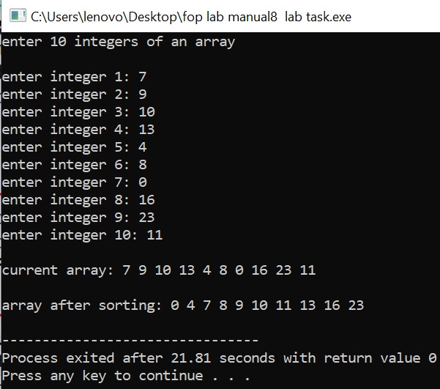

**Task 2**

**Bubble sorting:**

**#include<bits/stdc++.h>**

**using namespace std;**

**int main(){**

**int size=5,arr[size], temp=0;**

**for(int i=0;i<=size-1;i++){**

**cout<<"enter integer "<<i+1<<": ";**

**cin>>arr[i];**

**}**

**for(int w=0;w<size;w++){**

**for(int j=0;j<size-1;j++){**

**if(arr[j]>arr[j+1]){**

**temp=arr[j];**

**arr[j]=arr[j+1];**

**arr[j+1]=temp;**

**}**

**}**

**}**

**cout<<"Array after sorting: "<<endl;**

**for(int k=0;k<size;k++){**

**cout<<arr[k]<<" ";**

**}**

**return 0;**

**}**

**Output:**

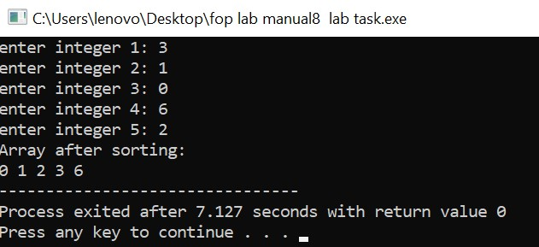

**Task 3**

**Average:**

**#include<iostream>**

**using namespace std;**

**int main(){**

**int size;**

**cout<<"enter the number of elements for the array"<<endl;**

**cin>>size;**

**int arr[size], sum=0;**

**cout<<"enter the desired elements in the array "<<endl;**

**for(int i=0;i<size;i++){**

**cin>>arr[i];**

**sum+=arr[i];**

**}**

**double avg=double(sum/size);**

**cout<<"the average of the entered array is "<<avg;**

**return 0;**

**}**

**Output:**

